December 2014
Volume 66, Issue 12
LGCA Bulletin

Special Interest Articles:

• Annual Meeting

• Counterfeiters

• 27th Annual Holiday Decorating Spectacular

“Your Neighborhood Newsletter for over 60 Years”
www.lgca.info

The LGCA Annual meeting will be held on Sunday, January 24, 2015 @ 2pm in the Clubhouse.
All Members in good standing (i.e. whose dues are current) are invited to attend to vote on the new LGCA Board of Directors.
Members who wish to run for a Board of Director position can submit their name for

Annual Meeting – LGCA Board Elections

LGCA Board Positions

The following are descriptions of the LGCA Board Positions:
(Executive Officers)
President: Presides at all meetings, has general supervision, direction, and control of the business & officers of the corporation.
Vice President: Shall perform the duties of the president in the absence or disability of he president.
Secretary: Keeps the meeting minutes.
Treasurer: Keeps and maintains the correct accounts of the business transactions of the corporation, makes bank deposits, and disburses funds of the corporation.

(Chairpersons)
Membership Promotion: Introduces prospective new members to the LGCA and answers any questions about the association.
Membership Records: Keeps track of membership dues paid and invoices members when their dues are due. (Cont. on page 4)

the ballot at either
the Annual meeting or with one of the Nomination Committee members.

Members: This is your chance to make a difference and see what your contribution can do to improve the clubhouse for all of our members!

We can accomplish
Wonders when we work together as a team toward a common goal!


Official judging will be Wednesday Dec 17th from 6pm – 8pm. Categories will be Grand Prize, Best Holiday Theme, Most Lights and Judges’ Favorite. Any question call Blair Newman of The Newman Real Estate Team at (562) 822-6532.—David Rosales, Blair Newman & Dave Emerson

Lakewood Gardens’ 27th Annual Holiday Decorating Spectacular

LGCA Fundraiser: Tamales

“Do I not destroy my enemies when I make them my friends?” – Abraham Lincoln
The LGCA will be taking pre-orders for Tamales and delivering them on Saturday, December 13th.
We will be offering:
Red Chile Chicken Tamales;
Red Chile Pork Tamales; and
Cheese Tamales
Tamales are $1.50 each or $15/dozen.
Pre-orders only!! We will be delivering only those orders that have been placed prior to the tamales being made. Order cutoff date is: Thurs, Dec 10th
For orders, please call Damaris Peredia (562) 881-7316 or Laura Havlik (626) 675-3097
Proceeds will go toward the purchase of a clubhouse security card reader system.

Household Hazardous Waste Center
Those of you with household hazardous waste may wait for the next local HHW/E-Waste disposal roundup in your area, but may not realize that we already have a free permanent collection center locally.

The EDCO Recycling & Transfer Center, located at 2755 California Ave, Signal Hill, CA 90755 holds a household hazardous waste collection day the 2nd Saturday of each month from 9am – 2pm (Rain or Shine.)

The EDCO Recycling & Transfer Center will accept:
Abrasive cleaners, air fresheners, antifreeze, asbestos, automotive products, bug spray, car batteries, chlorine bleach, (Cont on pg 4)

Having a Garage/Yard Sale?

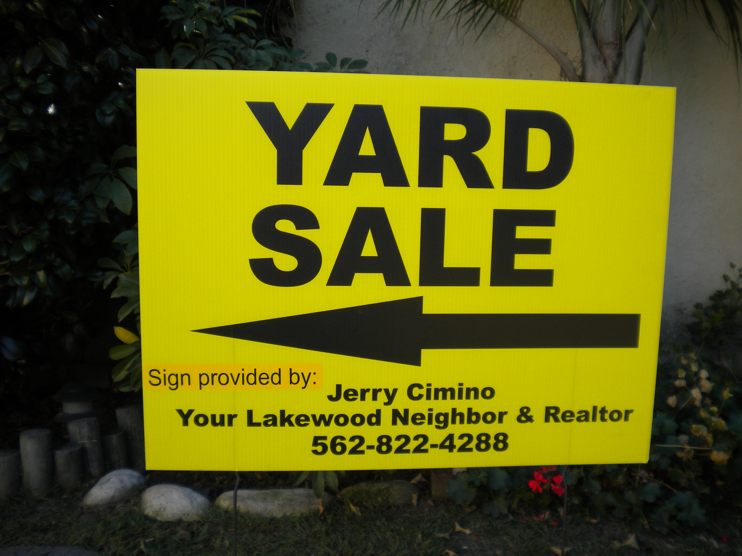

"Have you been considering having a Yard Sale? If so, just give me a call with the date and time of your Sale, and I will put the signs up for you.

... and by the way, I am never too busy for your Real Estate Needs"
Jerry Cimino – 562-822-4288

"Your Lakewood Gardens Neighbor and Realtor"

“Many people are good at talking about what they are doing, but in fact do little. Others do a lot but don't talk about it; they are the ones who make a community live.”
― Jean Vanier, Community And Growth

Lakewood Gardens 27th Annual Holiday Decorating Spectacular: Decorate your home for the holidays! Official judging will be on Wed, Dec 17th from 6pm – 8pm. Categories will be Grand Prize, Best Holiday Theme, Most Lights, and Judge’s Favorite
Sat, Dec 20th:
Project Shepard @ 6pm
Santa will be coming around in his sleigh picking up donations of canned & non-perishable food for Project Shepard to help those less fortunate. Please open your hearts and pantry to help those in need.
Then join us at the LGCA Clubhouse to meet Santa and enjoy snacks and hot chocolate!!
Sun, Jan 24th:
LGCA Annual Meeting @ 2pm

Upcoming Events

Don’t forget to keep current with your membership dues!

Keeping your membership in good standing allows you to use the pool and to rent the clubhouse for the discounted member rate!

Contact Tiffany Rodriguez (562) 754-4715 for the status of your membership.
LGCA Membership Totals:

62 Total Members

46 of these are Active Members
10 of these are Pending Renewals

6 of these are Lapsed/Renewal Overdue
Pumpkin Cheesecake Recipe ( Martha Stewart)
Ingredients:
(Crust) 1 ¼ cups graham cracker crumbs (from 10 crackers)
¼ cup sugar
4 Tbsp salted butter, melted

(Filing) 4 pkgs (8oz each) cream cheese, room temperature
1 cup canned pumpkin puree
4 large eggs, room temperature
1 ¼ cup sugar
2 Tbsp pumpkin pie spice
3 Tbsp all purpose flour
1 tsp vanilla extract
½ tsp salt

Directions: Preheat oven to 350º F, with rack in center
(For crust) In medium bowl, combine crumbs, sugar and butter, until moistened; press firmly into bottom of a 9-in springform pan. Bake until golden around edges, 10 to 12 minutes.
(For filing) Beat cream cheese until smooth; mix in flour (do not overmix.) Add pumpkin puree, pumpkin pie spice, vanilla and salt; mix until just smooth. Add eggs one at a time, mixing well before adding the next. Place springform pan on rimmed baking sheet. Pour filling into pan, and gently smooth top. Transfer to oven, reduce heat to 300º F. Bake 45 minutes. Turn off oven, let cheesecake stay in oven 2 hours more (without opening.) Remove from oven. Cool completely. Cover with plastic wrap and refrigerate until firm, at least 4 hours. Unmold before serving.

Board Positions (cont. from pg 2)

E
Clubhouse Rentals: Responsible for renting the clubhouse, collecting rental payment & security deposits, and inspecting the clubhouse after the rental (to return security deposit)
Entertainment: Plans and runs special events at the clubhouse throughout the year (dinners, Easter party, Ice Cream social, Halloween costume parade/party, Christmas party, etc.)
Bulletin Editor: Writes & prepares the Bulletin for distribution to the residents of Lakewood Gardens, keeps members and prospective members up to date on meetings and events.
Pool: Oversees the summer lifeguard schedule, door checkers, and blue/red cards
Clubhouse Maintenance: Responsible for keeping the clubhouse facilities & around the pool area clean.
Ways & Means: In charge of fundraising to meet the association’s annual budgetary needs
Webmaster: Oversees the updating of the website and maintains the calendar of events



This page intentionally left blank

Lakewood Gardens Civic Association
We held our very first Global Cardboard Challenge at the Clubhouse this year! The children came to create arcade games using cardboard and other recyclable items. It was a lot of fun—we may make this an annual event!
The annual Halloween Parade & Party had an impressive turnout, and I would like to thank all of the volunteers and attendees for making this a remarkable event! We had a lot of creative costumes and many neighborhood kids participated in the event—it was great to see you all there!
If you would like to know what events are coming up at the clubhouse or to view the photo gallery of past events, please check the website www.lgca.info. You can also register online for events, join the LGCA, and renew dues all in one place!
Wishing all of you and your families a happy and healthy Thanksgiving Day!


From the Editor
4217 Ashworth St
Lakewood, CA 90712

PResident
(562) 256-5827 Dan Cordero

Clubhouse rental:
(562) 715-1931 Chris Martinez
RentalsLGCA@gmail.com

Membership Promotion:
Jerry Cimino (562) 822-4288 & Juan Magallanes (562) 618-7272
MembershipLGCA@gmail.com

Bulletin Editor:
Laura Havlik (626) 675-3097
BulletinLGCA@gmail.com
Pool Chairperson:
Carrie Ahrens (562) 634-3839 & Sam Rushing (310) 261-0127
PoolLGCA@gmail.com

Check our new Website!
See us at:
http://www.lgca.info

Join our Facebook group:
Lakewood Gardens
And Facebook page:
Lakewood Gardens Neighbors

LGCA
4217 Ashworth St
(corner of Ashworth & Lakewood Blvd)
Lakewood, CA 90712
VALUED RESIDENT OF
LAKEWOOD GARDENS

